Activity breakdown  During the activity portion of the field trip, students must choose a minimum of one of the following activities to engage with, but they are welcome to try out more.  CreatIVE ANIMAL STORY  Students are invited to tell, draw, write, or act a story they created based on either an animal they witnessed during the field trip, one they have imagined, or an experience they had with an animal at a different time in their lives.  Shadow draw  Students can sketch a shadow they find during our time at NLWS. It can be a sketch of their own shadow, or a shadow cast be a structure, friend, etc.  Design a shelter  Students are invited to design their own shelter. In doing so, learners will consider what species they will be conserving, what strategies they may use, and how their shelter could potentially look like.  Assessment  Students will be assessed formatively through intentional conversation and observation during the field trip and summatively through submitting any of the three learning activities they choose to engage in. | Teacher’s Checklist for Day Trips  From school District #54  - Learning Objective of Field Trip  - Description of Activity  - Date and Time  - Transportation  - Supervising Teachers  - Volunteers  - Cost  - Emergency Contact   | 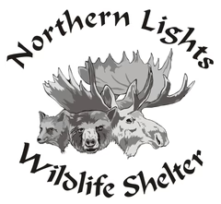  Field Trip to Northern Lights Wildlife Shelter  bROCHURE BY eMILY aNDERSON  Geared towards Grade 2-3, but can be catered to fit all grade levels  Great opportunity for land-based learning and local learning for students in the Bulkley Valley  Learning about conservation and key components in our environment
tentative shape of the day  9:00am – Bell rings  9:30am – Bus leaves  10:00am – Arrive at NLWS  10:15am – Snack  10:30am – Tour  12:00pm – Lunch  12:30pm – Organized Activities  Creative Animal Story  Shadow Draw  Design a Shelter  2:00pm – Clean Up & Thank You to NLWS  2:15pm – Leave NLWS  2:45pm – Arrive at school  3:00pm – Dismissal | Learning Intentions  The objective of this field trip is to learn about local wildlife and give students a glimpse into the career path of conservation.  BC’S Curriculum  Big Idea: Everything we learn helps us to develop skills  Curricular Competency: Identify and appreciate their personal attributes, skills, interests, and accomplishments  Content: Connections to community – jobs in the local community  design Considerations  An outdoor setting will ensure that students are making connections with the land and learning in an experiential way. There will be many movement breaks throughout the duration of the field trip and minimal engagement in heavy academic work. Students will mainly be reflecting verbally and engaging in organized activities as part of the visit. | nORTHERN lIGHTS wILDLIFE sHELTER  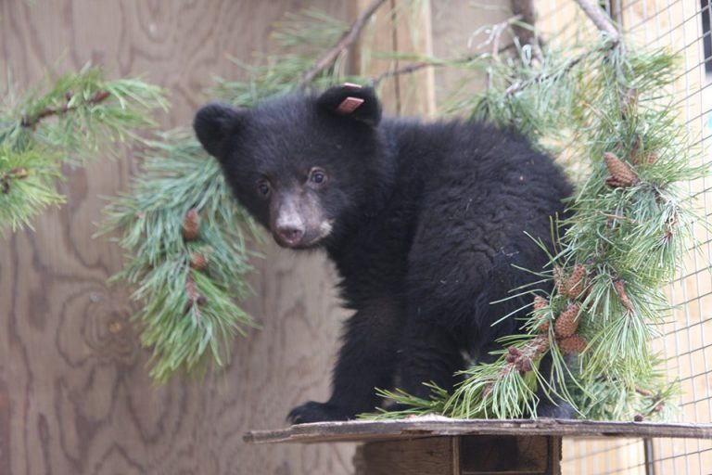  The Northern Lights Wildlife Shelter is a rehabilitation centre for wildlife that is located just outside of Smithers, BC. The objective of the programs is to help the wildlife that come into the shelter and return them to their natural habitat. The shelter ensures that animals are not having too much contact with humans so that they are able to reintegrate into the wild. The program has proven to be very successful in protecting local wildlife.  Call: 1-250-877-1181  Address:  17366 Telkwa High Rd  Smithers, BC  Canada  V0J 2N7

